Study on the Electron Action Mechanism of Hydrogen Adsorption and Activation on Platinum Clusters
Cao Peisen
Weifang Vocational College, Shandong, China, 262737
Keywords: Electron action; Hydrogen adsorption and activation; Platinum clusters
Abstract: Cyclic aromatic hydrocarbons occupy a certain proportion in the high boiling point fractions of petroleum and are difficult to convert. Hydrocracking to lighten polycyclic aromatic hydrocarbons is currently an effective way of conversion. As the first step of catalytic reaction, the adsorption of polycyclic aromatic hydrocarbons (PAHs) on the surface of catalytic materials is of great significance to the subsequent reaction process. In this paper, molecular dynamics and density functional theory (DFT) were used as research tools, and Nano-sized PT clusters were selected as adsorption models. Firstly, the adsorption mode of H2 on Pt clusters was analyzed from the frontier orbital point of view, and the changes of electron distribution of H2 on Pt clusters from physical adsorption to chemical adsorption were compared.

Introduction
Polycyclic aromatic hydrocarbons (PAHs) mainly exist in high boiling point fractions of petroleum. PAHs also account for a high proportion in secondary processing heavy oils such as coking wax oil (CGO) and catalytic cracking light cycle oil (FCC-LCO). Chemical adsorption of reactant molecules on the active site of catalyst is the premise of reactant molecular activation, and physical adsorption is the important reason for chemical adsorption. The adsorption of aromatic hydrocarbons on transition metals mainly depends on the interaction between the aromatic hydrocarbons' pi orbital and the d orbital of transition metals. At present, there is a basic consensus. However, most of these studies are based on the adsorption of non-substituted side chain aromatic hydrocarbons with fewer rings on the ideal metal surface, and there is still a certain gap with the actual reaction system. Therefore, improving the understanding of the adsorption of PAHs on the transition metal surface is of great significance to the modification of catalysts and the improvement of catalytic processing efficiency.

Research methods and model selection
2.1 Research methods
Using the module based on molecular dynamics and Monte Carlo principle, the initial adsorption conformation of the system can be obtained, and the adsorption sites with lower energy on the adsorbate can be searched. Quantum mechanics method is based on the non-localization of electrons in molecules. By solving the equation, we can study the structure and electronic properties of the system, and then describe the bonding action dominated by electrons. It is suitable for discussing the breakage or formation process of chemical bonds. DMol3 module was used to further optimize the initial adsorption conformation, and the energy, orbit and electronic structure of the adsorption system were analyzed with higher accuracy.
2.2 Model selection
Hydrocracking catalyst is a bifunctional catalyst composed of two essential components, hydrocracking component and acidic component. Hydrogenation activity is mainly provided by hydrogenation metals. According to activity and value, it can be divided into two categories: non-precious metals and precious metals. Among them, the sulfided bimetallic combination commonly used in non-noble metal hydrocracking catalysts is the active component of hydrogenation. According to the existing research, the sulfided catalyst is greatly affected by the active site of the catalyst in the actual reaction process, and the cooperation mechanism is more complex. Pt, as a noble metal hydrogenation component, has strong hydrogenation activity at near normal temperature and pressure. As an adsorption model, Pt is simple and applicable. Therefore, Pt is selected as the hydrogenation active component.
Hydrogenation components in bifunctional catalysts may exist as clusters. Clusters are atomic aggregates with smaller particle size than nanoparticles. Studies have shown that metal nanoparticles catalysts exhibit very high catalytic activity and selectivity. At present, there is still a limited understanding of the specific binding sites and modes between hydrogenation components and acidic components in bifunctional catalysts, so the hydrogenation catalyst model is simplified and the Pt cluster is constructed as the hydrogenation component model. Cluster size selection refers mainly to the study of metal clusters, and takes full account of the influence of the total number of atoms on the simulation time-consuming under the existing hardware conditions. Pt clusters with 5 atoms are chosen as the model of hydrogenation catalyst, labelled Pt₅, and the optimized structure is shown in figure 1.
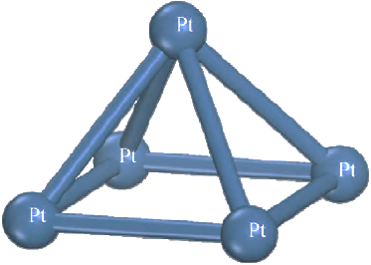
Figure 1 Pt₅ Cluster Model
The distance between Pt-Pt in the Pt-5 cluster model is basically consistent with the previous research results, and can be used as the hydrogenation center of this adsorption study.

Results analysis
3.1 Adsorption and activation dissociation of H2
In order to investigate the adsorption of polycyclic aromatic hydrocarbons on Pt₅ clusters, it is necessary to determine the feasibility of adsorption and dissociation of H2 on Pt₅ clusters. The single adsorption system is labelled as H₂-Pt₅ system. Firstly, the adsorption energy changes with the adsorption distance between H₂ and Pt₅ cluster of an H₂ molecule in the process of approaching Pt₅ cluster gradually, and the variation of the distance between two H atoms with the adsorption distance was investigated. Thus, the process of H₂ adsorbing on Pt₅ cluster and finally dissociating and activating was preliminarily determined. By looking for the centroid of H₂ and Pt₅ clusters respectively, and taking the distance between the two centroids as the adsorption distance, the results are shown in figure 2.
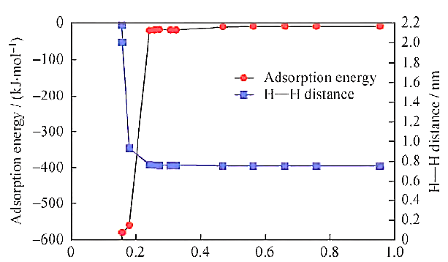
Figure 2 Effect of adsorption distance on H-H distance and adsorption heat of H₂-Pt₅ system
Analyzing the change of adsorption heat with adsorption distance of H₂-Pt₅ system, it can be seen that the adsorption heat released by the system is 19-22 kJ/mol when the adsorption distance approaches 0.22 nm, and the adsorption effect is weak. At this time, the adsorption state of H₂ on Pt₅ is physical adsorption. At the same time, it is found that the adsorption heat decreases slowly with the decrease of the adsorption distance of H₂-Pt₅ system, which shows that H₂ has an internal driving force to spontaneously adsorb on the surface of Pt₅ clusters.
3.2 Electronic mechanism of H2 dissociation in Pt5 clusters
Because the valence electron orbital of Pt atom is arranged as 5d⁹6s¹, there is an unpaired electron in the 5d orbital and 6s orbital, and H₂ has an empty antibonding orbit with low energy. The outer electrons of Pt may transfer from Pt atom to H₂ antibond orbit, which weakens H-H bond energy and promotes H₂ dissociation and chemical adsorption on Pt₅ surface, as shown in figure 3.
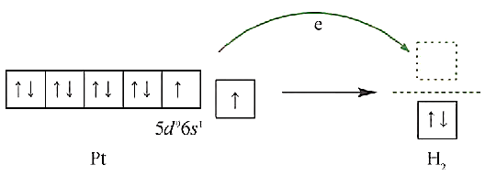
Figure 3 Orbital analysis of cluster interaction
The electron density distribution shows that the electron cloud density around H₂ molecule in the physical adsorption system is lower than that around Pt₅ cluster. The electron density on Pt₅ cluster is relatively high and mainly concentrated on two 3-Coordinated Pt atoms. After chemisorption, the electron density of Pt₅ clusters decreased slightly compared with that of H₂-Pt₅ system as a whole. The electron cloud densities near the two tri-coordinated Pt atoms at both ends of the cluster and the Pt atoms bonded to activated H decrease, while the electron densities on the unoccupied four-coordinated Pt atoms and activated H increase significantly. It can be seen that during the transition from physical adsorption to chemical adsorption, the electrons on several Pt atoms in the Pt₅ cluster migrate towards the active H side and transfer to the activated H side.
The unit charge analysis of adsorbate and adsorbent during the formation of physical and chemical mono-adsorption system of H₂ on Pt₅ cluster is shown in table 1 below.
Table 1 Charge distribution of the single molecular adsorptions systems
Adsorption system | Q/e
Adsorption system | Adsorbate | Adsorbent
H₂-Pt₅ | 0 | 0
2H-Pt₅ | 0.142 | -0.142
When H₂ approaches the critical distance from Pt₅ cluster to chemisorption, the outer electrons of adjacent Pt atoms migrate into the anti-bond orbit of H2 space, the interaction between H and H decreases, and the H-H bond energy decreases. At the same time, the interaction strength between H and Pt increases, this promotes the dissociation of H2 on the surface of Pt cluster, which is the intrinsic electronic mechanism by which H₂ can dissociate easily on Pt₅ clusters.

Conclusions
Through a series of preliminary studies on the single and co-adsorption of H₂ on Pt clusters, the internal mechanism of hydrogenation of H₂ and PAHs on transition metal catalysts is further clarified, which can provide theoretical guidance for the design and development of catalysts. By investigating the adsorption heat of H₂ at different distances from Pt clusters, it is known that H₂ can spontaneously physically adsorb onto the surface of Pt₅ clusters. H₂ can be easily dissociated and activated on Pt₅ surface. The reason is that the outer electrons of Pt atom can be filled into the anti-bond orbit of H₂ due to their arrangement characteristics, which weakens the interaction between H and H, and promotes the activation and dissociation of H₂ on the surface of Pt clusters.

References
[1] Zhang Hui. Quantum mechanics scenery of chemical adsorption[D]. Shenyang: Northeast University, 2014.
[2] Zhang Bai. Hydrocracking [M]. Beijing: Sinopec Press, 2008:180-181.
[3] Chengxi Hui. Theoretical study on electronic properties of copper-aluminium bimetallic clusters and adsorption properties of hydrocarbons by copper-aluminium bimetallic clusters[D]. Changchun: Jilin University, 2008.
[4] Zhang Shujuan. Density functional theory study on adsorption behavior of gas molecules on transition metal catalysts[D]. Beijing: China University of Geosciences, 2009.
[5] Gao Jingxing, Chen Linfeng. Progress in metal cluster catalysis[J]. Natural Gas Chemical Industry, 1988, (3): 12-22.
[6] Huang Jianquan. Application of metal clusters in catalysis[J]. Chemical Bulletin, 2014, (2): 35-43.

